This section provides user interface design descriptions that directly support construction of user interface screens. Detail the common behavior that all screens will have. Common look and feel details such as menus, popup menus, toolbars, status bar, title bars, drag and drop mouse behavior should be described here.

A screen transition diagram or table can be created to illustrate the flow of control through the various screens. Screens sketches (paper prototype) should be designed and included.

Common behavior of all screens:

All of the user interfaces will have the same feel and design standards other systems that the users may use since they follow the same design rules and guidelines that the company sets. Additionally, the user interfaces should be easy-to-use and easy-to-understand as different kind of personnel are using the system. The different user interfaces does have some common behavior. First, all the screens have the same navigation bar as it is meant to navigate through the different kinds of level of access and common functionalities that all the user. For instance, all of the user interfaces can have access to the company directory, a list of what teams they are working with, and their own time sheet of what hours they have worked. Another common behaviour all the screens share are certain menus they can use. For example, all of the users will have the same login screen as it utilizes a single sign-on mechanism for all of the authentication. Additionally, any user can access previous leave time requests made in the last calendar year.

Moreover, all the user screens should display the same pop-ups when entering certain information and error message whenever there is a mistake in processing any kind of request. For instance, entering the date and time on a form should follow the same format for all forms and all users. Specifically, when entering the date on any form, the menu should bring up a calendar with certain days shaded out due to them being invalid. While entering the time on any form should bring up a clock. Additionally, when certain invalid information is entered, like entering a date that has already passed, then the system should have a pop-up error message that states what the issue was.

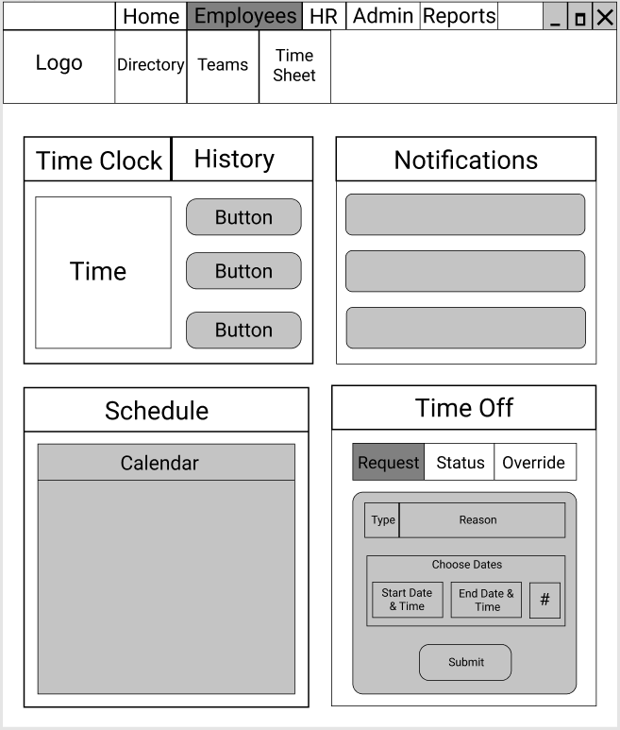

**Figure ?. Screen Sketch and Wireframe of Employee UI**

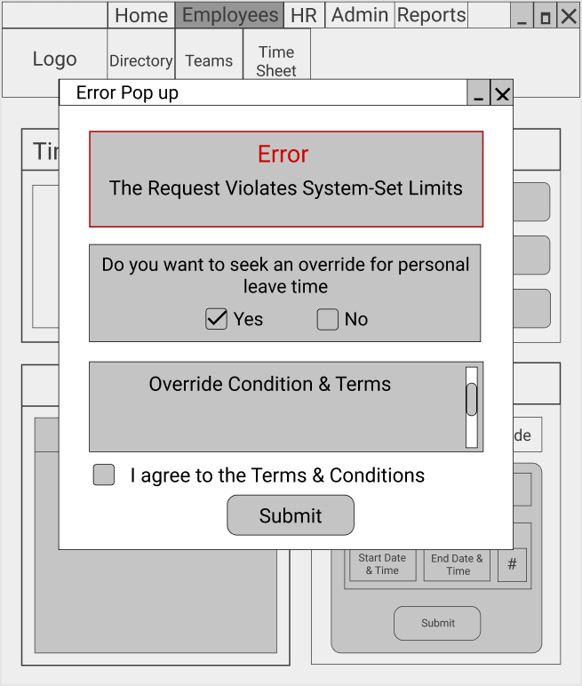

**Figure?. Screen Sketch and Wireframe of Possible Error that can Occur When Request Violates Rule-Based System**

To illustrate the flow of control through the various screens a Windows Navigation Diagram (WND) is made. The digram helps show the relationship between all screens, forms, and reports that are used by the Vacation Tracking System (VTS). The first window that any user must access is the same, which is the *Login Screen*. The *Login Screen* is can then transition into the different user windows once the user successfully logs in by clicking on the *Sign in* button. Once the user logs in, depending on the user they go to their specific menu. If an employee logs in then they are taken to the *Employee Menu* window, which consists of 2 buttons. One button is the *Create the Leave Time* button which when pressed transitions to the *Leave Time Request Form*. Once the user enters the correct information, they can submit the form by pressing the *Confirm Leave Time Request* button. Clicking the button will then lead to a report on the *Leave Time Request Notification*. The other button is the *Access Previous Calendar Requests* which brings up a report of previous leave time requests made in the last calendar year.

If a manager logs in then they are taken to the *Manager Menu* window, which consists of 3 buttons. One button is the *Approve Leave Time* button which is used to approve or deny a leave time request made by an employee under them. Once the user, clicks on the *Approve Leave Time* button then they receive a report of the *Request Status Change Notifications*. Another button is the *Award Personal Time* button which is used to directly award an employee’s personal leave time. Once the user clicks on the *Award Personal Time* button, they are taken to the *Personal Time Request Form*. Once the user enters the necessary information in the form they can submit the form by clicking on the *Confirm Personal Time*. Once clicking on this button, then they receive a report of the *Personal Time Request Notification*. The final button the user can click on in the *Manager Menu* is the *Access Previous Calendar Requests* button which has the same functionality across all screens.

If an HR representative logs in then they are taken to the *HR Menu* window, which consists of 3 buttons. One button is the *Override Restricted Actions* button which begins the process of overriding an action restricted by the rules. By clicking on the *Override Restricted Actions* button, the user is taken to the *Override Restricted Actions Form*. Once the user enters the correct information, they can submit the form by clicking on the *Confirm Override* button. Upon clicking the *Confirm Override* button and submitting the form, the user then receives a report for the *Override Status Notification & Override Log* as the system logs in every override. Another button is the *Retrieve Required Information & Changes* button which is used to allow HR to retrieve required employee information and changes. Clicking this button will take the user to the *Required Employee Information & Changes Report*. The final button the user can click on in the *HR Menu* is the *Access Previous Calendar Requests* button which has the same functionality across all screens.

If a systems administrator logs in then they are taken to the System Administration Menu window, which consists of 2 buttons. One button is the *Override Restricted Actions* button and the other button is the *Access Previous Calendar Requests* button. These buttons have the same functionality across all screens.

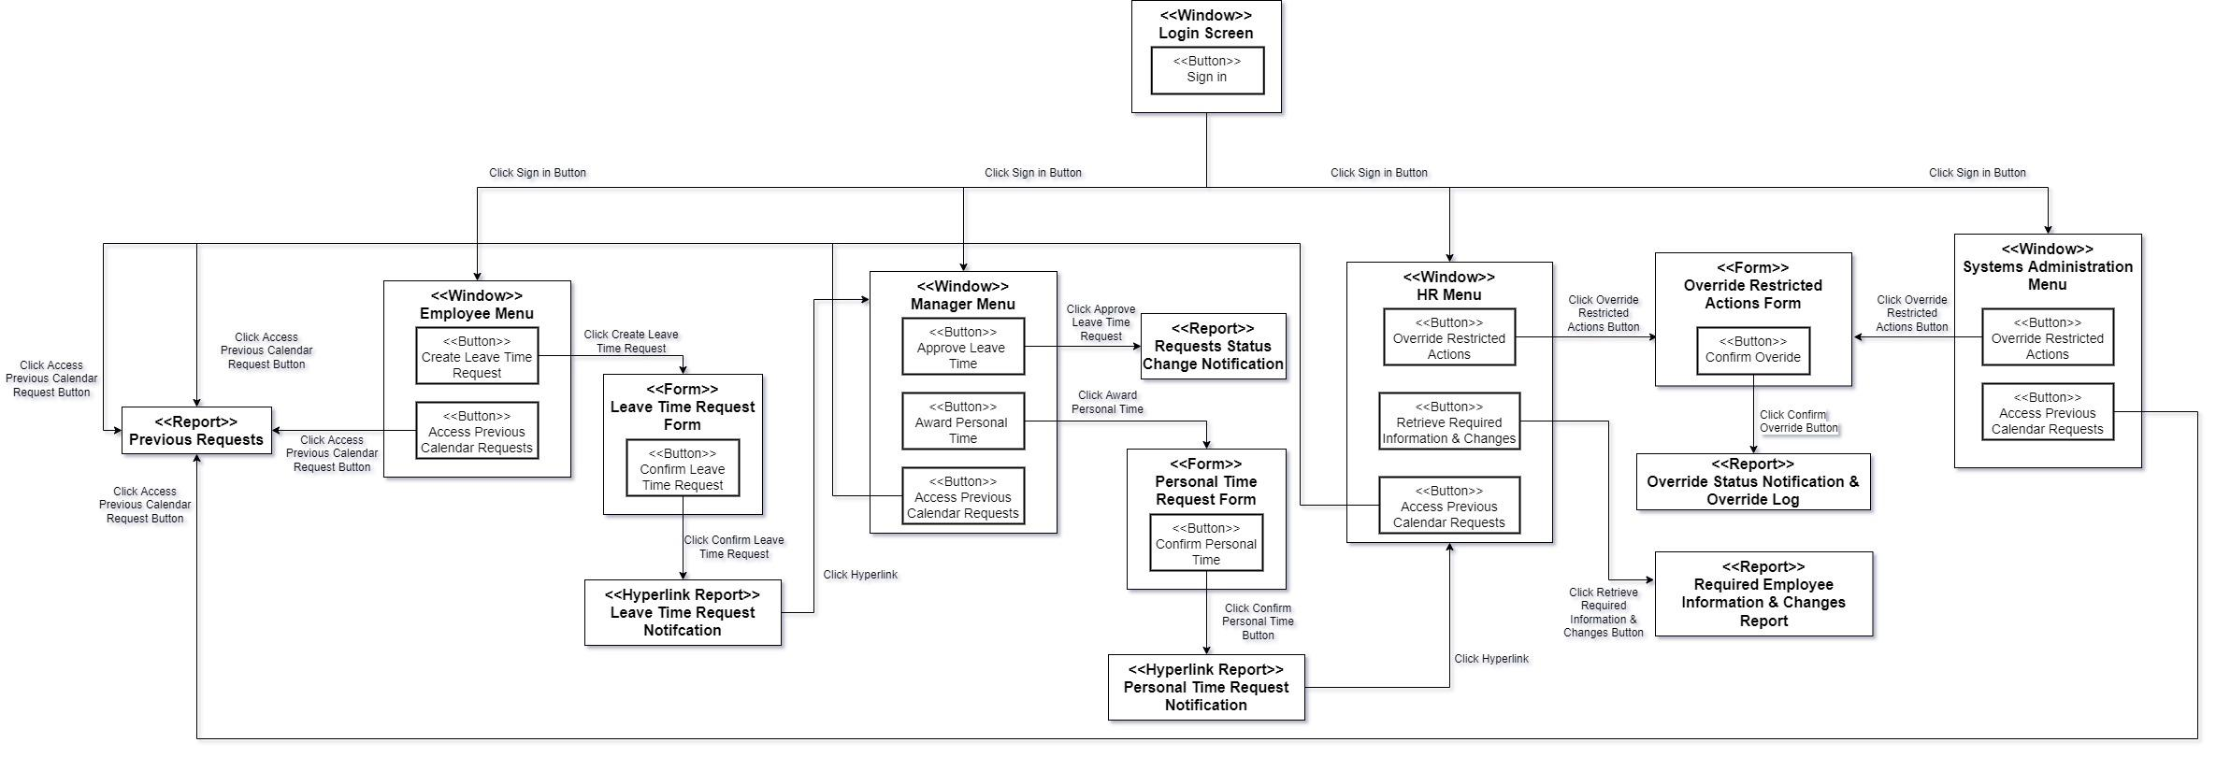

**Figure?. Windows Navigation Diagram for Overall System**